Contents:
Introduction : 3
System overview: 4
Requirements Analysis: 5
ERD diagram: 6
1. Entities Description 6
2. Relationships Summary 6
3. ERD Diagram: 7
Logical Database Design: 8
Sample SQL Queries: 9
1. Insert Example: 9
2. Select Example: 9
3. Update Example: 9
4. Delete Example: 9
Full code: 10
Conclusion: 12

Introduction :

- The ElderCare Management System is a database project designed to manage the daily operations of a residential care facility for elderly individuals. This system aims to organize resident information, room assignments, staff details, medical records, medications, payments, and visitors.

- The goal of this project is to build a structured, normalized database that supports efficient data retrieval, integrity, and real-world functionality for nursing home operations.

System overview:
The system supports several operational processes:
- Registering residents and assigning them to rooms.
- Managing staff responsible for daily care.
- Recording medical information and medications.
- Tracking payments made by residents or their families.
- Registering visitor details.

Primary Users:
- Receptionists / Admin Staff
- Nurses / Caregivers
- Medical Staff
- Accounting Personnel

Requirements Analysis:
Functional Requirements:
- The system must store personal information of residents.
- Each resident must be assigned to one room.
- Staff members must be registered and linked to multiple residents.
- The system must record medical records for each resident.
- Medications given to residents must be stored.
- Payments made by residents must be tracked.
- Visitor logs must be recorded.
Non-Functional Requirements:
- Usability: The system should be easy to understand.
- Performance: Queries should retrieve data quickly.
- Security: Sensitive data such as medical information must be protected.
- Reliability: The database should minimize errors and maintain data integrity.

ERD diagram:

1. Entities Description
Residents – Stores personal and medical-related identifying information.
Rooms – Contains details about each room in the facility.
Staff – Represents caregivers and administrative workers.
MedicalRecords – Records diagnoses, notes, and dates.
Medications – Tracks medications assigned to residents.
Payments – Saves payment details for each resident.
Visitors – Logs visitor names and visit dates.

2. Relationships Summary
From Table | To Table | Relationship Name | Cardinality | Participation
Residents | Rooms | Assigned_to | N:1 | Resident → Room: Mandatory
Room → Residents: Optional
Residents | Staff | Assigned_staff | N:1 | Resident → Staff: Mandatory
Staff → Residents: Optional
Residents | MedicalRecords | Has_medical_record | 1:N | Resident: Optional
MedicalRecord: Mandatory
Residents | Medications | Takes_medication | 1:N | Resident: Optional
Medication: Mandatory
Residents | Payments | Makes_payment | 1:N | Resident: Optional
Payment: Mandatory
Staff | Payments | Recorded_by | 1:N | Staff: Optional
Payment: Optional
Residents | Visitors | Receives_visit | 1:N | Resident: Optional
Visitor: Mandatory

3. ERD Diagram:

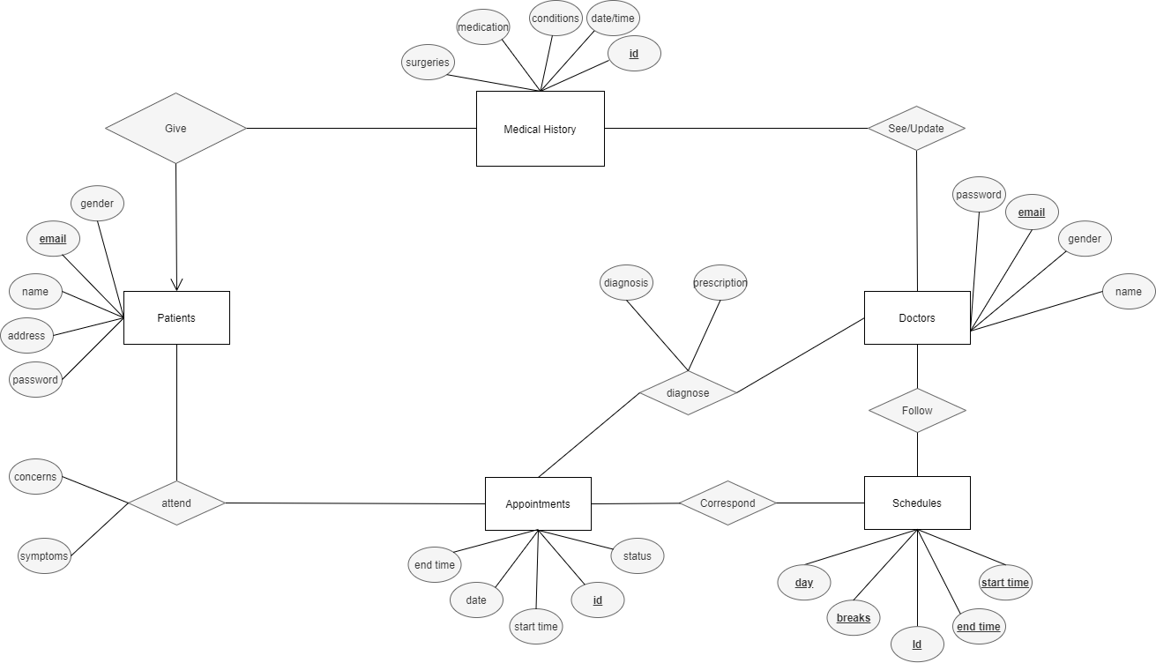

Logical Database Design:
Tables and Keys:
- Residents(ResidentID PK, FirstName, LastName, Age, Gender, Phone, AdmissionDate, RoomID FK, StaffID FK)

- Rooms(RoomID PK, RoomNumber, Floor, Capacity)

- Staff(StaffID PK, FullName, Position, Phone)

- MedicalRecords(RecordID PK, ResidentID FK, Diagnosis, Notes, RecordDate)

- Medications(MedicationID PK, ResidentID FK, MedicationName, Dosage, StartDate, EndDate)

- Payments(PaymentID PK, ResidentID FK, StaffID FK, Amount, PaymentDate, Method)

- Visitors(VisitorID PK, ResidentID FK, VisitorName, VisitDate)

Sample SQL Queries:

Insert Example:

INSERT INTO Room (room_no, capacity, type) VALUES
(101, 1, 'single'),
(102, 2, 'double'),
(103, 1, 'single'),
(104, 2, 'double'),
(105, 1, 'single');

INSERT INTO Bill (resident_id, bill_date, amount, description, paid) VALUES
(1, '2023-01-31', 1500.00, 'Monthly care fee', 1),
(2, '2022-11-30', 1200.50, 'Medical supplies', 0),
(3, '2023-02-28', 1800.75, 'Room and board', 1),
(4, '2022-09-30', 950.25, 'Therapy sessions', 1),
(5, '2023-03-31', 1400.00, 'Medication costs', 0),
(6, '2022-12-31', 1100.90, 'Activity fees', 1),
(7, '2023-04-30', 1600.40, 'Nursing care', 0),
(8, '2022-10-31', 1300.60, 'Dietary supplements', 1),
(9, '2023-05-31', 1700.20, 'Doctor visits', 1),
(10, '2022-09-30', 1000.00, 'Medication and Therapy', 0),
(11, '2023-06-30', 1250.35, 'Special care', 1),
(12, '2022-08-31', 1350.70, 'Rehabilitation', 0),
(13, '2023-07-31', 1550.85, 'Emergency services', 1),
(14, '2022-07-31', 1150.45, 'Pharmacy', 1),
(15, '2023-08-31', 1650.95, 'Consultation fees', 0),
(16, '2022-06-30', 1050.55, 'Transportation', 1),
(17, '2023-09-30', 1750.05, 'Mental health support', 1),
(18, '2022-05-31', 1450.25, 'Nutrition plan', 0),
(19, '2023-10-31', 1850.15, 'Equipment rental', 1),
(20, '2022-04-30', 1950.65, 'Miscellaneous', 0);

2. Select Example:
SELECT FirstName, LastName, RoomNumber
FROM Residents
JOIN Rooms ON Residents.RoomID = Rooms.RoomID;

3. Update Example:
UPDATE Rooms
SET Capacity = 3
WHERE RoomID = 2;

4. Delete Example:
DELETE FROM Visitors
WHERE VisitorID = 5;

Full code:
USE ElderCare;

-- Table1: Room

CREATE TABLE Room(
id INT IDENTITY(1,1) PRIMARY KEY,
room_no INT UNIQUE NOT NULL,
capacity INT NOT NULL,
type VARCHAR(50) NOT NULL --SINGLE OR DOUBLE
);

--Table2: Resident

CREATE TABLE Resident(
id INT IDENTITY(1,1) PRIMARY KEY,
Fname VARCHAR(100) NOT NULL,
Lname VARCHAR(100) NOT NULL,
DOB DATE NOT NULL,
gender VARCHAR(50) NOT NULL CHECK(gender IN ('Male', 'Female')),
admission_date DATE NOT NULL,
room_id INT,
contact VARCHAR(100) NOT NULL,
notes TEXT,
FOREIGN KEY (room_id) REFERENCES Room(id) ON DELETE SET NULL
);

--Table3: Staff

CREATE TABLE Staff(
id INT IDENTITY(1,1) PRIMARY KEY,
Fname VARCHAR(100) NOT NULL,
Lname VARCHAR(100) NOT NULL,
role VARCHAR(50) NOT NULL CHECK(role IN ('Doctor', 'Nurse', 'Admin')),
phone VARCHAR(50) NOT NULL,
hire_date DATE
);

--Table4: Medical_Record

CREATE TABLE Medical_Record(
id INT IDENTITY(1,1) PRIMARY KEY,
resident_id INT,
record_date DATETIME,
diagnosis TEXT,
treatment TEXT,
doctor_id INT,
FOREIGN KEY (resident_id) REFERENCES Resident(id) ON DELETE CASCADE,
FOREIGN KEY (doctor_id) REFERENCES Staff(id) ON DELETE SET NULL
);

--Table5: Medication

CREATE TABLE Medication(
id INT IDENTITY(1,1) PRIMARY KEY,
resident_id INT,
med_name VARCHAR(100) NOT NULL,
dose VARCHAR(50) NOT NULL,
frequency VARCHAR(100) NOT NULL,
start_date DATE NOT NULL,
end_date DATE ,
FOREIGN KEY (resident_id) REFERENCES Resident(id) ON DELETE CASCADE
);

--Table6: Visit

CREATE TABLE Visit(
id INT IDENTITY(1,1) PRIMARY KEY,
resident_id INT,
visitor_name VARCHAR(100) NOT NULL,
relation VARCHAR(100) NOT NULL,
visit_datetime DATETIME NOT NULL,
notes TEXT,
FOREIGN KEY (resident_id) REFERENCES Resident(id) ON DELETE CASCADE
);

--Table7: bill

CREATE TABLE Bill(
id INT IDENTITY(1,1) PRIMARY KEY,
resident_id INT,
bill_date DATE NOT NULL,
amount DECIMAL(10, 2) NOT NULL,
description TEXT,
paid BIT DEFAULT 0,
FOREIGN KEY (resident_id) REFERENCES Resident(id) ON DELETE CASCADE
);

Conclusion:
This project successfully demonstrates the design and implementation of a relational database system for a nursing home.
The system improves organization, data management, and record tracking.
It ensures that resident care, staff responsibilities, and financial operations are properly documented.
Future improvements may include adding activity tracking, meal planning, automated alerts, and advanced reporting features.

